**Functional Document**

|  |  |
| --- | --- |
| **Application** | NGERP – Centra |
| **Service Bundle** | Inventory Management |
| **Service Request** | Move Confirmation (VAS,Metro,Borrow) |

**Description:**

In **Compiere (NGERP - Centra)**, the users can able to view consignment movement documents with an "In Progress" status in the **Move Confirmation (VAS, Metro, Borrow)** screen.

**Workflow Process:**

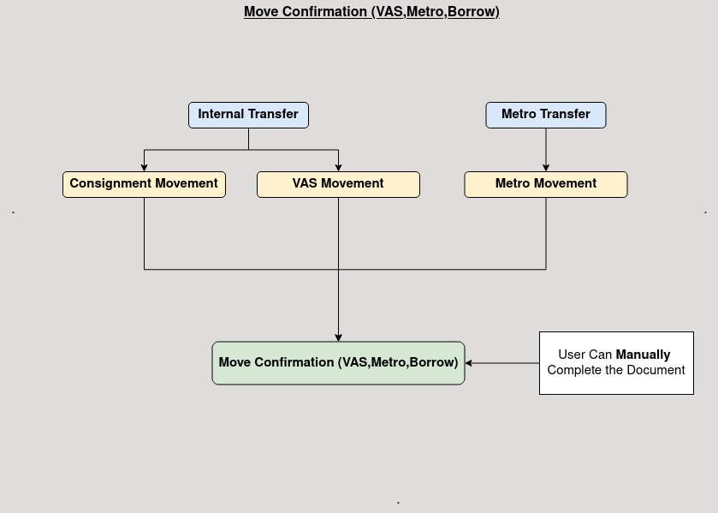

**Business Rules:**

* It is visible in both **HQ** and **ROW.**
* Editing of consignment movement documents should not be allowed once they are in the Move Confirmation screen, only allowing completion.
* Voided consignment movement documents also visible in the open move confirmation screen.
* The "Void" action should be restricted for documents with a Draft status in the Move Confirmation screen.
* Documents with a Completed status should not be allowed to be voided in the Move Confirmation screen.